Name : Jayaprakash Nivas
Reg.No.: 192424238

DSA0601 Data Handling and Visualization

Slot A
CO2 – Assessment Test 5 (AT2)
Visualization Development Exercise

Instructions:
For each question, write the program in the specified language (R or Python), generate the required visualization, and answer the interpretation sub-questions clearly with justification.

CO2_AT2 — Visualization Development Exercise
Topics: Directory of Visualizations · Visualizing Amounts · Visualizing Distributions

Question 1 — Chart Selection (Topic 1: Directory of Visualizations)
Task: For each scenario below, name the single best chart type from the directory (Amounts / Distribution / Proportion / x–y Relationship / Geospatial / Network / Temporal / Multivariate) and justify your choice in 1–2 sentences. No code required for this question.
- Comparing the population of 8 countries in the current year.
Answer : Best Chart Type: Bar Chart
Justification:
A bar chart is the most suitable choice for comparing the population of different countries because it clearly displays the values for each category. It allows easy comparison of population sizes across all eight countries.
- Showing how delivery times vary across 5 courier companies.
Answer : Best Chart Type: Box Plot
Justification:
A box plot is ideal for showing the distribution of delivery times because it displays the median, spread, and
possible outliers. It makes it easy to compare the variation in delivery times among the five courier companies.
- Showing the proportion of a household budget spent on rent, food, transport, and savings.
Answer : Best Chart Type: Pie Chart
Justification:
A pie chart effectively shows how each expense contributes to the total household budget. It helps viewers
understand the percentage share of each spending category.
- Showing the relationship between hours studied and exam marks for 50 students.
Answer : Best Chart Type: Scatter Plot
Justification:
A scatter plot is best for showing the relationship between two numerical variables. It helps identify whether
increased study hours are associated with higher exam marks.
- Showing average temperature for each month across 3 different cities at once.
Answer :Best Chart Type: Line Chart
Justification:
A line chart is suitable because it shows how temperature changes over time. Multiple lines can be used to compare monthly temperature trends across the three cities.
- Showing which airports are directly connected by flight routes.
Answer :Network Diagram
Justification:
A network diagram clearly represents airports as nodes and flight routes as connecting edges. It effectively visualizes direct connections between airports.

Question 2 — Bar Plot (Topic 2: Amounts)
Dataset — app_downloads.csv

App_Category | Downloads_Millions
Social Media | 58
Gaming | 46
Productivity | 27
Finance | 19
Health & Fitness | 33
Education | 24

Task:
  - Create a horizontal bar plot of Downloads_Millions by App_Category, sorted in ascending order.
  - Use a color gradient (single hue, varying shade) so bar color intensity reflects download count.
  - Add the exact value as a text label at the end of each bar.
Python: use pandas to build the DataFrame and matplotlib.pyplot.barh (or seaborn.barplot with orient="h").
R: use a data.frame, ggplot2::geom_col() with coord_flip() (or geom_col() plus aes(y = reorder(...))).

R Code :
library(ggplot2)
app<-data.frame(
App_Category=c("Social Media","Gaming","Productivity","Finance","Health & Fitness","Education"),
Downloads_Millions=c(58,46,27,19,33,24)
)
app<-app[order(app$Downloads_Millions),]
ggplot(app,aes(x=reorder(App_Category,Downloads_Millions),y=Downloads_Millions,fill=Downloads_Millions))+
geom_col()+
coord_flip()+
geom_text(aes(label=Downloads_Millions),hjust=-0.2)+
scale_fill_gradient(low="lightblue",high="darkblue")+
labs(title="Downloads by App Category",
x="App Category",
y="Downloads (Millions)")+
theme_minimal()

R Output :
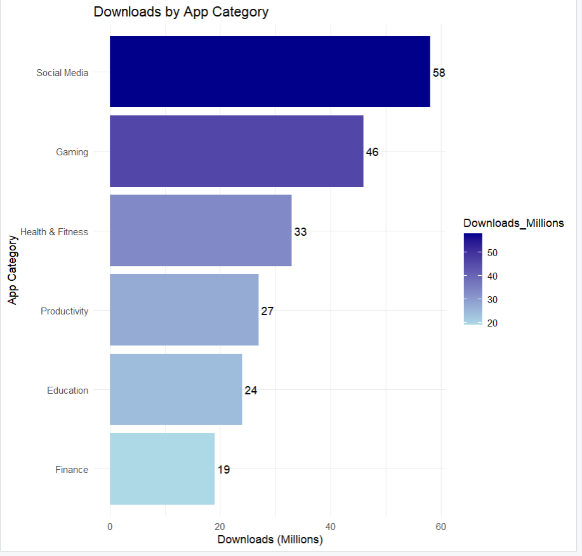
Interpretation
The horizontal bar chart compares the download counts of different app categories. Social Media has the highest number of downloads (58 million), while Finance has the lowest (19 million). The color gradient highlights categories with higher downloads using darker shades, making the comparison easier.

Question 3 — Grouped/Stacked Bars, Dot Plot & Heatmap (Topic 2: Amounts)
Dataset — website_traffic.csv

Device | Month | Visits_000s
Desktop | Jan | 45
Desktop | Feb | 48
Desktop | Mar | 42
Desktop | Apr | 50
Mobile | Jan | 80
Mobile | Feb | 88
Mobile | Mar | 95
Mobile | Apr | 102
Tablet | Jan | 20
Tablet | Feb | 18
Tablet | Mar | 17
Tablet | Apr | 15

Task (produce all four views from the same dataset):
- Grouped bar chart: Visits_000s by Month, grouped by Device.
Answer :
R Code :
library(ggplot2)
traffic<-data.frame(
Device=c("Desktop","Desktop","Desktop","Desktop","Mobile","Mobile","Mobile","Mobile","Tablet","Tablet","Tablet","Tablet"),
Month=c("Jan","Feb","Mar","Apr","Jan","Feb","Mar","Apr","Jan","Feb","Mar","Apr"),
Visits=c(45,48,42,50,80,88,95,102,20,18,17,15)
)
ggplot(traffic,aes(x=Month,y=Visits,fill=Device))+
geom_col(position="dodge")+
labs(title="Website Traffic by Device and Month",
x="Month",
y="Visits (000s)")+
theme_minimal()
R Output :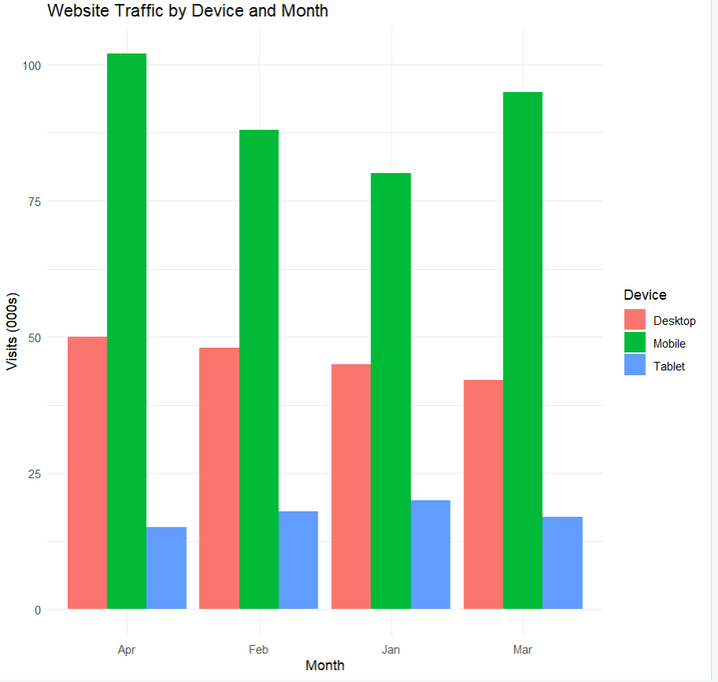
- Stacked bar chart: same data, stacked by Device within each Month, so each bar shows total monthly traffic.

R Code :
library(ggplot2)

traffic<-data.frame(
Device=c("Desktop","Desktop","Desktop","Desktop","Mobile","Mobile","Mobile","Mobile","Tablet","Tablet","Tablet","Tablet"),
Month=c("Jan","Feb","Mar","Apr","Jan","Feb","Mar","Apr","Jan","Feb","Mar","Apr"),
Visits=c(45,48,42,50,80,88,95,102,20,18,17,15)
)

ggplot(traffic,aes(x=Month,y=Visits,fill=Device))+
geom_col(position="stack")+
labs(title="Total Website Traffic by Month",
x="Month",
y="Visits (000s)")+
theme_minimal()

R Output :
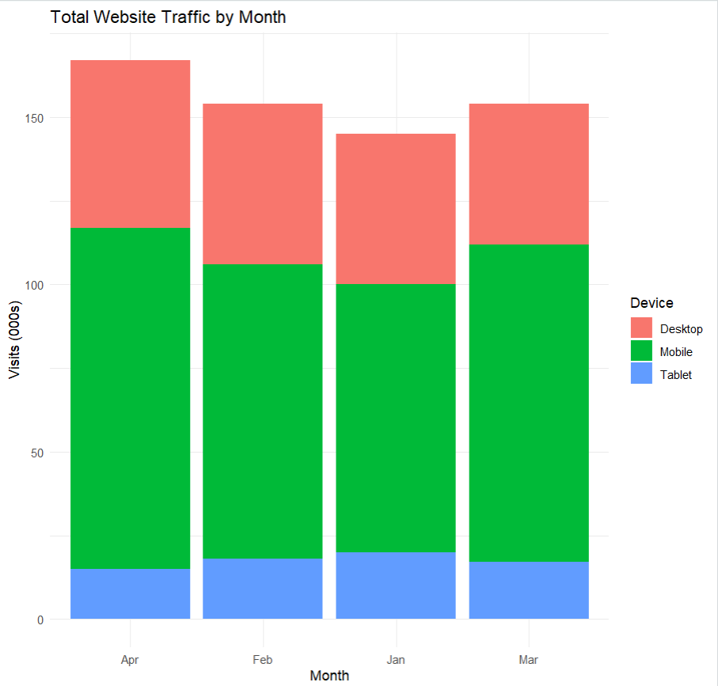

- Dot plot: total 4-month traffic per device (sum across months), ranked from highest to lowest.
R Code :
library(ggplot2)
library(dplyr)
traffic<-data.frame(
Device=c("Desktop","Desktop","Desktop","Desktop","Mobile","Mobile","Mobile","Mobile","Tablet","Tablet","Tablet","Tablet"),
Month=c("Jan","Feb","Mar","Apr","Jan","Feb","Mar","Apr","Jan","Feb","Mar","Apr"),
Visits=c(45,48,42,50,80,88,95,102,20,18,17,15)
)
total<-traffic%>%
group_by(Device)%>%
summarise(Total=sum(Visits))%>%
arrange(desc(Total))
ggplot(total,aes(x=reorder(Device,-Total),y=Total))+
geom_point(size=4,color="blue")+
geom_text(aes(label=Total),vjust=-0.5)+
labs(title="Total 4-Month Traffic by Device",
x="Device",
y="Visits (000s)")+
theme_minimal()

R Output
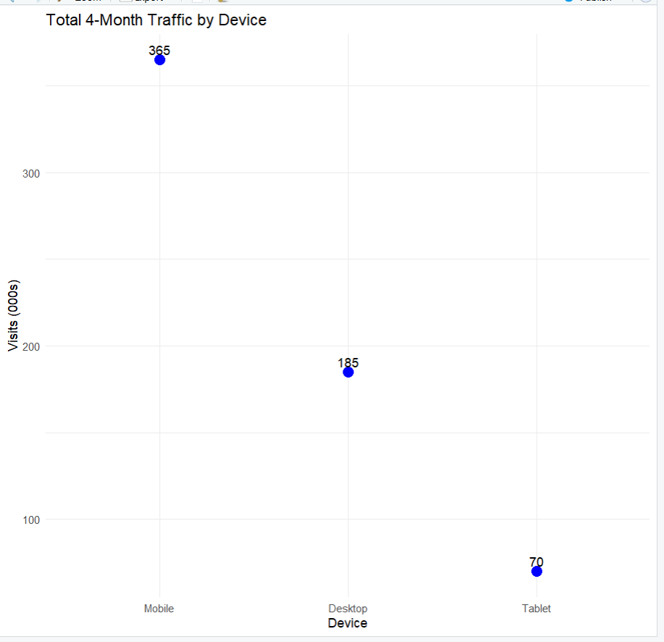

- Heatmap: Device (rows) × Month (columns), color-encoded by Visits_000s.
R Code :
library(ggplot2)

traffic<-data.frame(
Device=c("Desktop","Desktop","Desktop","Desktop","Mobile","Mobile","Mobile","Mobile","Tablet","Tablet","Tablet","Tablet"),
Month=c("Jan","Feb","Mar","Apr","Jan","Feb","Mar","Apr","Jan","Feb","Mar","Apr"),
Visits=c(45,48,42,50,80,88,95,102,20,18,17,15)
)

ggplot(traffic,aes(x=Month,y=Device,fill=Visits))+
geom_tile(color="white")+
geom_text(aes(label=Visits))+
scale_fill_gradient(low="lightblue",high="darkblue")+
labs(title="Website Traffic Heatmap",
x="Month",
y="Device")+
theme_minimal()

R Output :
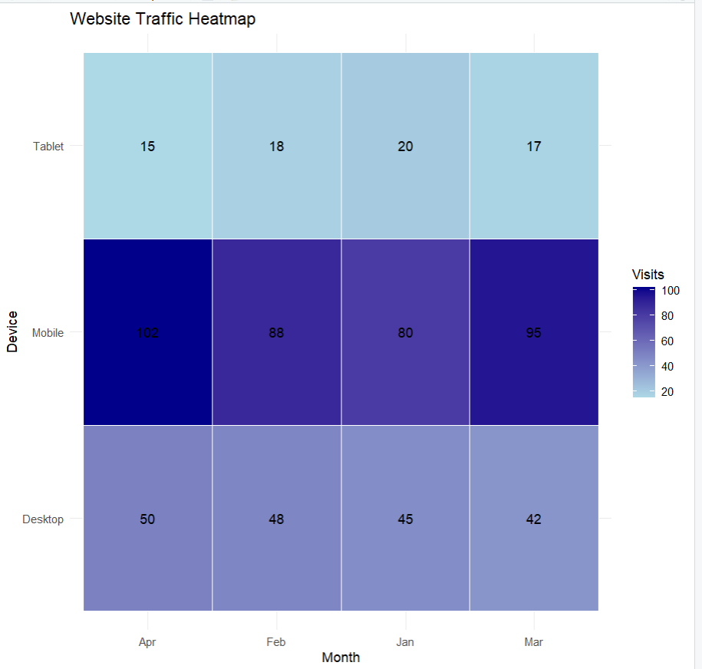

Python: pandas.pivot_table to reshape; matplotlib/seaborn for grouped/stacked bars, seaborn.heatmap for the heatmap, matplotlib.pyplot.scatter (or plt.plot with markers) for the dot plot.
R: tidyr::pivot_wider where needed; ggplot2::geom_col(position = "dodge") for grouped, position = "stack" for stacked, geom_point() for the dot plot, geom_tile() for the heatmap.

Question 4 — Violin & Ridgeline Plots (Topic 3: Distributions)
Dataset — generate synthetically for reproducibility:
Route A: 50 delivery times (minutes) ~ Normal(mean=32, sd=6) Route B: 50 delivery times (minutes) ~ Normal(mean=28, sd=4) Route C: 50 delivery times (minutes) ~ Normal(mean=40, sd=9)
Route D: 50 delivery times (minutes) ~ Normal(mean=35, sd=5)
(Set a random seed of 7 in both Python and R so results are consistent across languages.)

Task:
- Violin plot: delivery-time distribution by route (all 4 routes on one plot), with an embedded boxplot or median marker.
R Code :
library(ggplot2)
set.seed(7)
routeA<-rnorm(50,32,6)
routeB<-rnorm(50,28,4)
routeC<-rnorm(50,40,9)
routeD<-rnorm(50,35,5)
time<-c(routeA,routeB,routeC,routeD)
route<-c(rep("Route A",50),rep("Route B",50),rep("Route C",50),rep("Route D",50))
delivery<-data.frame(Route=route,Time=time)
ggplot(delivery,aes(x=Route,y=Time,fill=Route))+
geom_violin(trim=FALSE)+
geom_boxplot(width=0.1)+
labs(title="Delivery Time Distribution by Route",
x="Route",
y="Delivery Time (Minutes)")+
theme_minimal()

R Output :
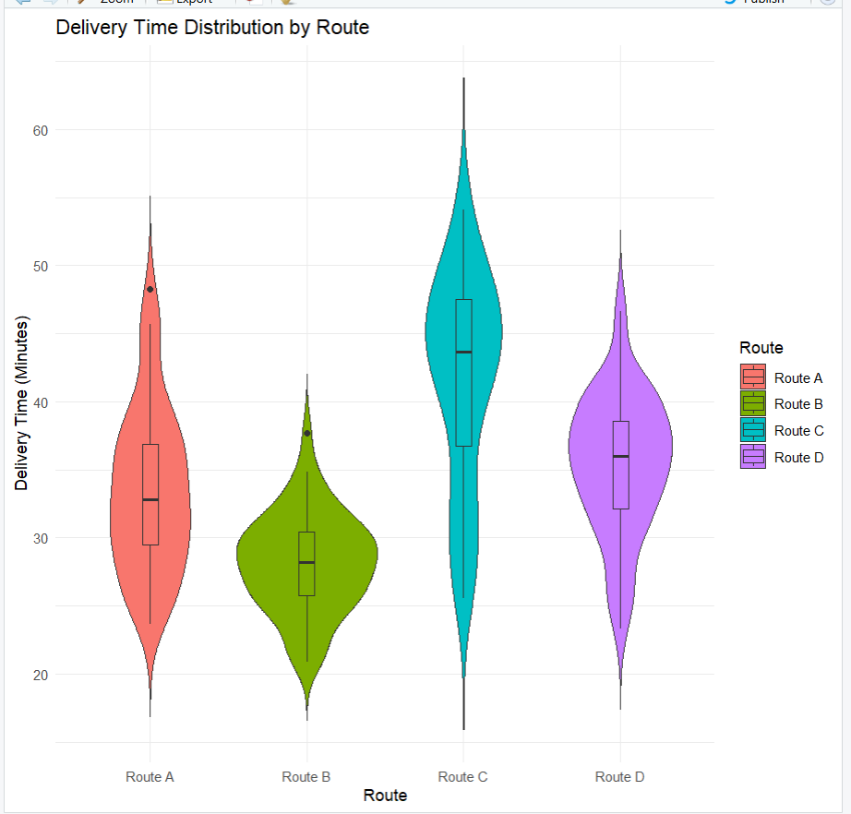
- Ridgeline plot: same 4 routes, overlapping density curves, ordered by mean delivery time (fastest at the bottom).
R Code :
library(ggplot2)
library(ggridges)
set.seed(7)
routeA<-rnorm(50,32,6)
routeB<-rnorm(50,28,4)
routeC<-rnorm(50,40,9)
routeD<-rnorm(50,35,5)
time<-c(routeA,routeB,routeC,routeD)
route<-c(rep("Route A",50),rep("Route B",50),rep("Route C",50),rep("Route D",50))
delivery<-data.frame(Route=route,Time=time)
means<-aggregate(Time~Route,delivery,mean)
delivery$Route<-factor(delivery$Route,levels=means$Route[order(means$Time)])
ggplot(delivery,aes(x=Time,y=Route,fill=Route))+
geom_density_ridges()+
labs(title="Ridgeline Plot of Delivery Times",
x="Delivery Time (Minutes)",
y="Route")+
theme_minimal()

R Output :
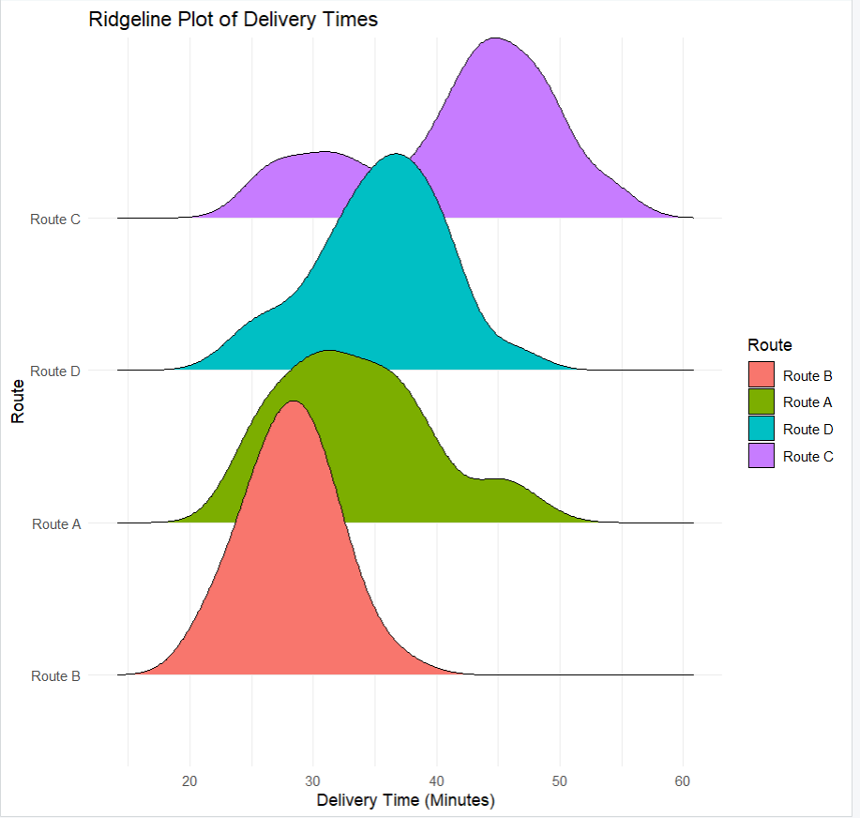
Python: numpy.random.normal to generate data, seaborn.violinplot for the violin plot, joypy.joyplot (or a stacked seaborn/matplotlib kdeplot FacetGrid) for the ridgeline.
R: rnorm() to generate data, ggplot2::geom_violin() for the violin plot, ggridges::geom_density_ridges() for the ridgeline.

Question 5 — Histograms & Density Plots (Topic 3: Distributions)
Dataset: Use a built-in dataset available in both languages.
  - Python: seaborn.load_dataset("iris") → use the petal_length column.
  - R: the built-in iris dataset → use the Petal.Length column.

Task:
- Plot a histogram of the chosen continuous variable with 20 bins.
R Code :
library(ggplot2)

ggplot(iris,aes(x=Petal.Length))+
geom_histogram(bins=20,fill="skyblue",color="black")+
labs(title="Histogram of Petal Length",
x="Petal Length",
y="Frequency")+
theme_minimal()
R Output :
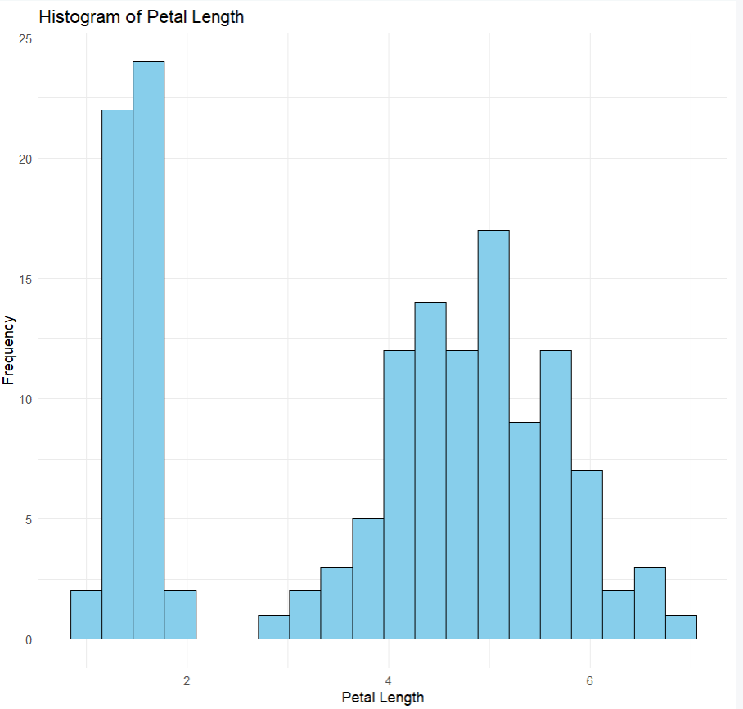
- Overlay a kernel density estimate (KDE) curve on the same plot.
R Code :
library(ggplot2)

ggplot(iris,aes(x=Petal.Length))+
geom_histogram(aes(y=after_stat(density)),bins=20,fill="skyblue",color="black")+
geom_density(color="red",linewidth=1)+
labs(title="Histogram with Density Curve",
x="Petal Length",
y="Density")+
theme_minimal()

R Output :
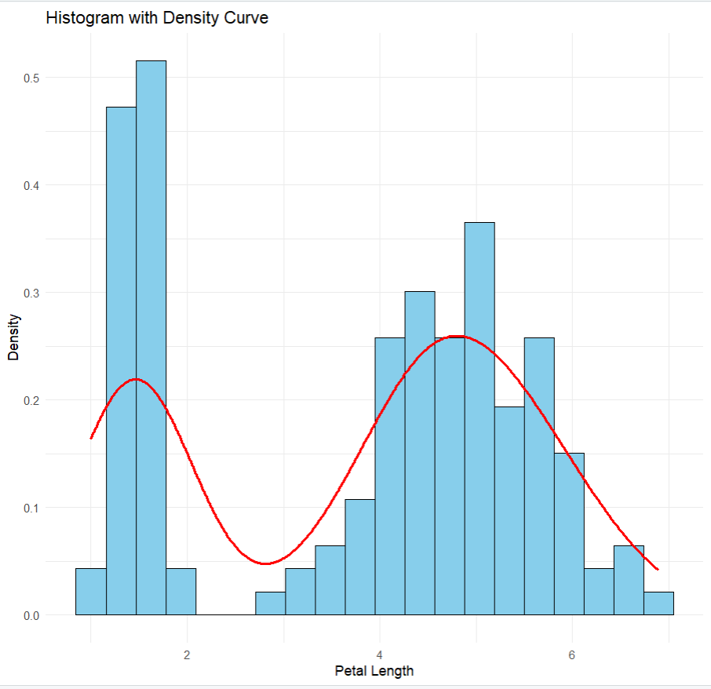
- Repeat both, split/colored by species (setosa, versicolor, virginica), to compare distribution shape across groups.
R Code :
library(ggplot2)

ggplot(iris,aes(x=Petal.Length,fill=Species))+
geom_histogram(aes(y=after_stat(density)),bins=20,alpha=0.5,position="identity")+
geom_density(aes(color=Species),linewidth=1)+
labs(title="Petal Length Distribution by Species",
x="Petal Length",
y="Density")+
theme_minimal()

R Output :
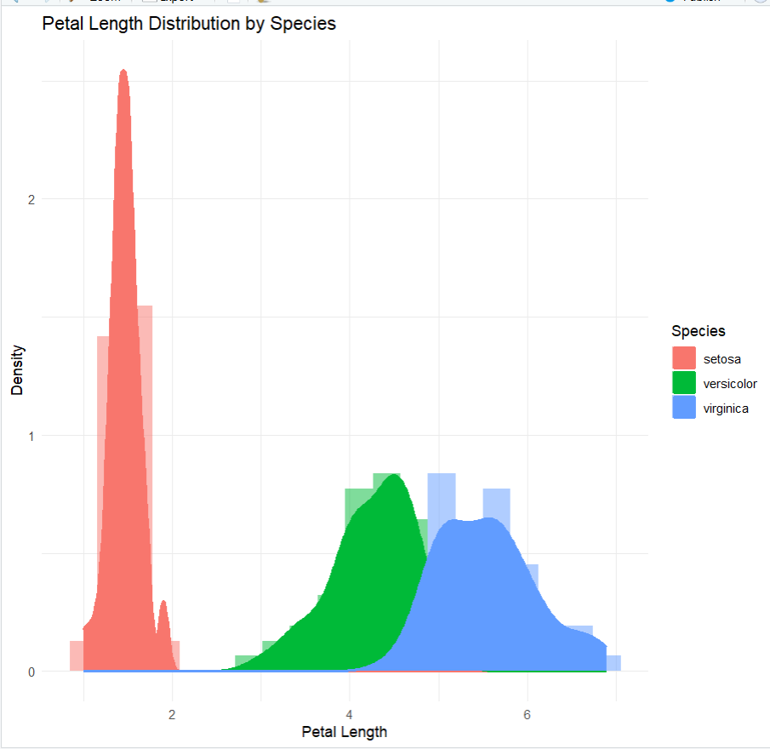
Python: seaborn.histplot(..., kde=True) or matplotlib.pyplot.hist + scipy.stats.gaussian_kde.
R: ggplot2::geom_histogram() combined with geom_density() (use after_stat(density) so scales match), with fill = mapped to Species for the grouped version.

Submission Checklist
  - Q1: written chart-type justifications (no code)
  - Q2: bar plot — Python + R
  - Q3: grouped bar, stacked bar, dot plot, heatmap — Python + R
  - Q4: violin plot, ridgeline plot — Python + R
  - Q5: histogram + density (overall and grouped) — Python + R
  - Each chart has a title, axis labels, and a short written interpretation

